Oral Presentations for ISOPS-13
- Oral Presentations will be self-recorded 8 min talks.
- Presentations will be followed by a 2-minute Questions & Answers session
- The entire symposium will be archived but will not be published.
- The format for PowerPoint presentations is 16:9.

Presentation Recording with Microsoft PowerPoint
- For the preparation of your oral presentation, you need PowerPoint 365.
- PowerPoint has an integrated recording function, so you do not need an external program.
- You can easily convert Power Point presentation to Video. Please see:
https://www.youtube.com/watch?v=4-bhjcBGaDU
- Please see from the following link how you can add voice to your PowerPoint presentations.
https://www.youtube.com/watch?v=3uk4CU7uobM

Please consider these points while recording your presentation
Preparation
Video and lighting
- Your background should be neutral, ideally a white wall, the webcam should be at eye level. If you work at a laptop with a built-in webcam, it is recommended to raise the laptop by 15 – 20 cm.
- Choose a comfortable sitting position and set your camera image so that you can be seen centrally with head and shoulders.
- Please avoid from using a virtual background.
Sound
- Ideally use in-ear headphones with built-in microphone for the recording, as this ensures a higher quality than the computer microphone.
- Make sure that there is no noise in the background.
While Recording
- Speak straight towards the microphone and look into the camera as often as possible.
- Don’t touch your microphone and speak clearly.

Start recording mode
- Start your PowerPoint presentation and, under “Slide Show”, select “Record Slide Show”. The recording mode will open.
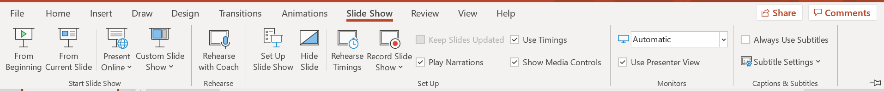

Set up recording
- Select “headset microphone” as microphone. If you would like to record with your webcam, select “Microsoft Camera Front” and activate the camera via the respective button.
- Click on the “Turn camera preview on” button. The camera image should now be shown in the lower right hand corner.
- Make sure that important parts of the slides are not covered by the webcam image.
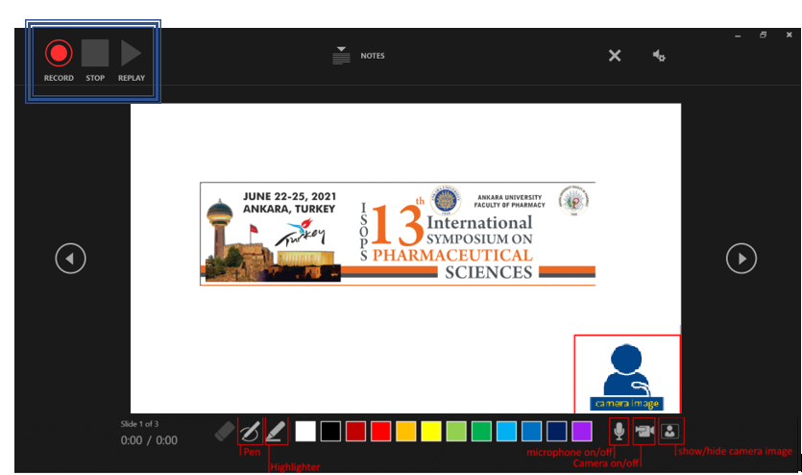
Record presentation
- Start the recording by clicking on the “Record” button. After a short countdown, the recording starts and you can start your presentation. Go from slide to slide as usual by hitting the arrows or clicking on the respective buttons to the right and left. The recordings are saved sequentially on the respective slides, so you might want to make sure not to talk while switching slides.
- Be aware that the mouse cursor is not recorded. If you would like to highlight something, use the pen or the marker in the live mode.
- End your presentation by clicking the “Stop” button.

Check presentation
- Navigate to the first slide of the presentation and view the recording (“play from beginning”). Should anything not be satisfactory, you can delete the recording individually for the slides and record again. Select “clear recordings” in the upper right section ("X") – then either select "clear recordings on current slide” or "clear recordings on all slides". Start a new recording, without changing slides, as otherwise existing recordings are overwritten. Save the new recording by clicking on the “Stop” button again.
If you want to delete your presentation

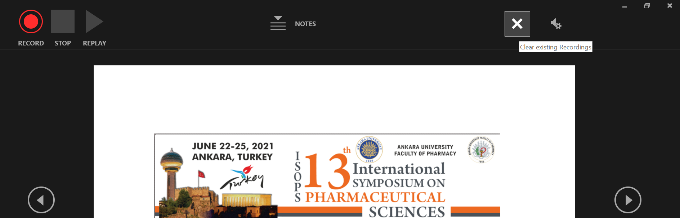

Export presentation
- Export as video: Select “File” -> “Export” -> “Create a video”. Here, you can define the resolution. Please make sure to export the video in HD (720p). Via the button “Create video”, you can export the recording as an .mp4 file.

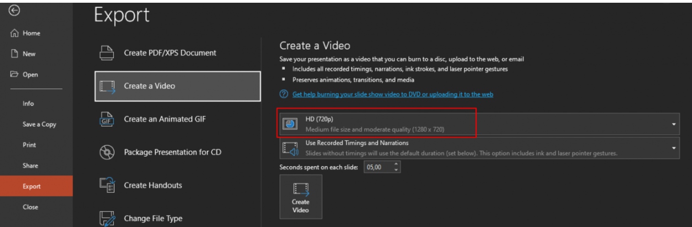

- Please convert your file to mp4 and follow the file naming protocol below while saving your presentation
- PresenterSurname_ FirstName_ORAL_Department (5 words max)

- Please send your presentation video to isops2021@gmail.com via WeTransfer until June 13, 2021.

https://wetransfer.com/

- Please make sure that your presentation video does not exceed 2 GB.

- Participants who do not have the latest version of the PowerPoint can record their videos via Zoom App.

If you have any questions, please contact the conference secretariat: isops@ankara.edu.tr

